Natchez: Where the river is wide
and the history runs deep.
Natchez Spring Pilgrimage
April 3-7, 2020

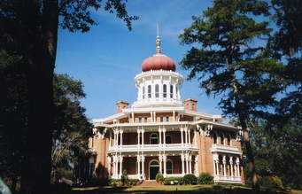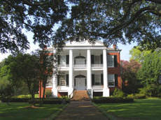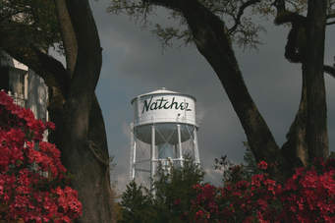

A southern historical and horticultural experience

No drivers needed on this trip as we’ll be relaxing playing cards, reading, or visiting in our very own motor coach with our very own driver at the wheel. We’ll be on our way to a southern historical and horticultural experience. Natchez Spring Tours are, in a word, extraordinary! With the azaleas in bloom and spring bursting out all over, this should be one of Bittersweet’s extraordinary trips. Natchez is known as a quaint southern city with incomparable charm where hospitality and history go hand in hand. Founded in 1716, Natchez is the oldest city on the Mississippi River. For over 80 years, the Natchez Pilgrimage has provided exclusive tours and events opening the doors to some of America’s most exquisite historic homes and gardens to visitors from all over the globe. You’ll experience landmark homes and gorgeous landscapes unlike any other place, with one of the most important collections of 19th century architecture and cultural landscapes in the country. Brimming with history, these sites help tell the multi-layered, multi-cultural stories of the city of Natchez.
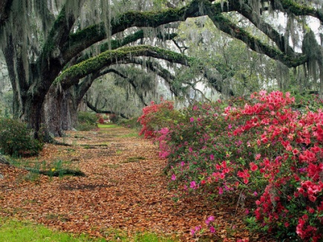
The Natchez Spring Pilgrimage started in 1932 when the ladies of the local garden club opened their family homes to the public, initiating the first tour of its kind in America and igniting the spirit of historic preservation in this region. Since then, 30 antebellum mansions, all of which are on the National Register of Historic Places and 12 of which are National Historic Landmarks have been preserved. Natchez has been named as one of the top ten destinations to visit in the United States. The stunning antebellum mansions also earned Natchez a listing in the New York Times best-seller, 1000 Places to See before You Die.
Before we head to Natchez, we’ll make several stops along the way to visit the Crystal Bridges Museum in the Ozark Forest in Bentonville, AR and P. Allen Smith’s Moss Mountain Farm near Little Rock. On the way home, we’ll visit Garvan Woodland Gardens in Hot Springs before returning to Jefferson City.
P. Allen Smith’s Moss Mountain Farm
P. Allen Smith is an award-winning designer and gardening and lifestyle expert. He is the host of two public television programs, P. Allen Smith's Garden Home, P. Allen Smith's Garden to Table and the syndicated 30-minute show P. Allen Smith Gardens. Smith is one of America's most recognized and respected garden and design experts, providing ideas and inspiration through multiple media venues.
We’ll visit Allen’s Arkansas home, Moss Mountain Farm, which is an epicenter for promoting the local food movement, organic gardening and the preservation of heritage poultry breeds. The farm serves as a place of inspiration, education, and conservation. In addition to the tour, we’ll have lunch there giving us the opportunity to taste the goodness from the farm.
Crystal Bridges Museum, Bentonville, AR
At this stop, we’ll experience the magic of Crystal Bridges Museum. Discover the power of art and architecture with the beauty of nature while exploring our galleries, trails, and grounds. The architecture of Crystal Bridges is as stunning and inspirational as the artwork housed inside it. In a ravine surrounded by native Ozark forest, the Museum’s muscular gray concrete walls rise up from the bedrock, banded in rough cedar and curved to echo the shape of the hillside. The roofs of the Museum’s bridges, covered in deep brown copper, rise like mounds of earth across the still ponds. Designed by architect Moshe Safdie, the structures are meant to provide views of the surrounding landscape and play up the interaction between architecture, art, and nature.

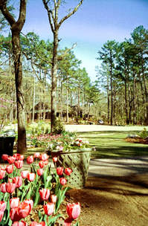
Garvan Woodland Gardens – Hot Springs, AR
On our way home, we’ll explore Garvan Woodland Gardens. From the dynamic architectural structures to the majestic botanical landscapes, Garvan Woodland Gardens offers breathtaking sights (and fantastic photo opportunities) at every turn. Built by self-taught gardener Verna Cooke Garvan, the gardens are home to rare shrubs and trees including camellias, magnolias, and 160 different types of azaleas. As we know Mother Nature has a mind of her own, but we hope to be on time for the spring tulip extravaganza.

The Nitty Gritty Details Limit 45
Due to the increase in Bittersweet membership, the trip is being offered to members only until January 16, 2020. If space is available after January 16, 2020, guests may sign up.
Deadline for all: February 20, 2020 or until filled.
Deposit: $200 due by January 16, 2020 for members to hold your space. If applicable, the deposit for guests will be $200 due by February 1, 2020 on a first come, first served basis. The balance for all will be due by February 20, 2020. Transportation costs will vary depending upon the number of travelers, which will affect the final balance.

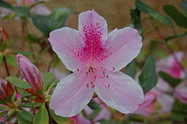
If you must cancel, it will be your responsibility to find another member to purchase your ticket. You are encouraged to purchase travel insurance for the entire trip when you make the deposit. You may choose the insurance company of your choice. One company to consider is Allianz at https://www.allianztravelinsurance.com/ .

We must have at least 35-40 travelers to make the trip. If we do not have enough participation by the deadlines, the trip may be cancelled and your deposit refunded.

Natchez Trip Itinerary
(Subject to Change)
April 3-7, 2020
(

Day 1 (Friday)
7:30 a.m. - Depart Jefferson City by Motor Coach
(Jefferson City to Bentonville – 4 hr, 21min)
11:30 a.m. Lunch – tbd – Joplin (JC to Joplin – 3 hr, 37 min)
1:00 p.m. - Depart for Bentonville, AR (Joplin to Bentonville – 1 hr, 8 min)
2:00 p.m. - Visit Crystal Bridges in Bentonville (no charge) (golf carts can be reserved)

4:30 p.m. – Depart for Van Buren, AR (1 hr, 12 Min)

5:45 p.m.- Check in at hotel (tbd)
6:30 p.m. – Dinner (tbd)
Day 2 (Saturday)
6:30 – Breakfast at hotel
7:15 – Travel to Moss Mountain Farm (2 hr, 16 min)
9:45 a.m. – Arrive at Moss Mountain Farm, Roland, AR
10:00 a.m. - 2:00 p.m. – Guided Tour and Lunch at Moss Mountain Farm
2:15 p.m. – Depart for Natchez, MS
(Moss Mountain Farm to Natchez, 5 hrs, 12 min)
7:30 p.m. - Arrive Natchez - Check into Natchez Grand Hotel
8:00p.m - Cooking School and Catered Dinner at Natchez Grand Hotel
Day 3 (Sunday)
7:00 a.m. - Breakfast at Hotel
7:00 a.m. – River Walk – on your own walk or run along the river (optional)
8:30 a.m. – City Tour on Motor Coach with Step on Guide
10:00 a.m. – Palm Sunday Catholic Mass at historic St. Mary’s Basilica (optional)
Time tbd – Non-Denominational Protestant Services (optional)
Free time to explore Natchez (optional)
11:00 a.m. – Guided tour of historic St. Mary’s Basilica
12:00 noon - Sunday Brunch at the Carriage House at Stanton Hall
1:00 – 4:00 p.m. - Visit Antebellum Homes & Gardens starting at Stanton Hall
4:30 p.m. – Biscuit Cooking School at Regina’s Kitchen (optional)
In this class, learn how to make some of the most talked about biscuits west or east, north or south of the Mississippi. One of Regina's well-trained staff will guide you through baking the same recipe she uses in her own home.
6:30 p.m. - Dinner at Antebellum Monmouth Historic Inn
Day 4 (Monday)
7:30 – 8:30 - Breakfast at Hotel
9:00 a.m. – Visit Antebellum Homes
12:00 noon – Free Time and Lunch on Your Own
1:30 p.m. - Depart for Hot Springs (5 hrs, 32 min)
7:00 p.m. - Overnight in Hot Springs, AR (tbd)
7:30 – Dinner tbd
Day 5 (Tuesday)
7:30 – Breakfast at Hotel

9:00 a.m. – Depart for Garvan Woodland Botanical Gardens, Hot Springs
9:30 a.m. – Tour Garvan Woodland Botanical Gardens (golf carts can be reserved)
11:30 a.m. -- Depart for Jefferson City from Hot Springs (6 hrs, 36 min.)
12:30 p.m. – Lunch tbd
7:00 (approx.) – Arrive Jefferson City

________________________________________________________________
Registration Form
Natchez Trip Deposit

Deposit $200.00 Balance (tbd) due February 20, 2020
Make checks payable to Bittersweet Garden Club.

I will be sharing a room with _________________________________________________
I request a single room ______________

The deposit is non-refundable after January 16, 2020 . Another person may go in your place, but you will be responsible for arranging payment from the other person.
You can purchase travel insurance very easily online if you have concerns that you may have to cancel this trip for medical, financial, or other important reasons. There are many companies to choose from which is your choice. Among others, you may look at Allianz at www.allianztraPvelinsurance.com/ . For the greatest protection, you should consider purchasing travel insurance when you make your reservation. Be sure to check all exclusions, such as pre-existing conditions.
Name: ______________________________________ Date:________________________

